Project Design Phase-II
Technology Stack (Architecture & Stack)
Date | 30 September 2026
Team ID | MKU201Team76ab4df35a238dc999eb5e6de
Project Name | Streamlining IT Procurement: Automating Standard Laptop Orders with Flow Designer
Maximum Marks | 4 Marks
Technical Architecture:
The Deliverable shall include the architectural diagram as below and the information as per the table1 & table 2
Project: Automated Standard Laptop procurement using ServiceNow Flow Designer
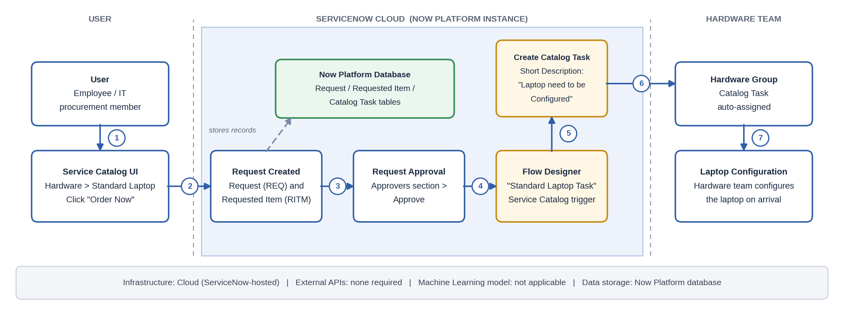
Table-1 : Components & Technologies:
S.No | Component | Description | Technology
1. | User Interface | Employees / IT procurement users order the Standard Laptop through the ServiceNow Service Catalog (Hardware > Standard Laptop > Order Now) and check the Order Status. | ServiceNow Service Catalog (Now Platform web UI)
2. | Application Logic-1 | "Standard Laptop Task" flow created in the Global application, run as System User, with Service Catalog as the trigger. | ServiceNow Flow Designer
3. | Application Logic-2 | Create Catalog Task action mapped to the Requested Item record; Short Description and Description set to "Laptop need to be Configured"; Approval set to Approved. | Flow Designer action: Create Catalog Task
4. | Application Logic-3 | Request approved by the approver, and the catalog task is automatically assigned to the Hardware group for laptop configuration. | ServiceNow Approvals and Assignment Group (Hardware)
5. | Database | Stores the Request, Requested Item and Catalog Task records generated by each laptop order. | ServiceNow Now Platform database
6. | Cloud Database | Database service hosted with the ServiceNow cloud instance. | ServiceNow Cloud Instance
7. | File Storage | No separate file storage required; record data is kept within the platform. | ServiceNow Now Platform (built-in storage)
8. | External API-1 | Not required; the whole procurement workflow runs inside ServiceNow. | Not applicable
9. | External API-2 | Not required. | Not applicable
10. | Machine Learning Model | Not used in this project. | Not applicable
11. | Infrastructure (Server / Cloud) | Application deployment on Cloud (ServiceNow instance accessed through a web browser)  Local Server Configuration: Not required  Cloud Server Configuration: ServiceNow-hosted instance | Cloud (ServiceNow Now Platform)
Table-2: Application Characteristics:
S.No | Characteristics | Description | Technology
1. | Open-Source Frameworks | No open-source framework required; the solution is built with the low-code Flow Designer. | ServiceNow Flow Designer (low-code)
2. | Security Implementations | Flow runs as System User; catalog task restricted to the Hardware group; request needs approval by the approver; role-based access on records. | ServiceNow roles and access controls, approvals
3. | Scalable Architecture | Cloud platform with separate presentation (catalog), logic (flow) and data layers; the same flow pattern can be reused for other catalog items. | ServiceNow cloud platform, Flow Designer
4. | Availability | Runs on the ServiceNow-hosted cloud instance; once activated the flow is available for every new Standard Laptop request. | ServiceNow cloud instance
5. | Performance | Catalog tasks are created automatically by the flow without manual steps, reducing delays and user wait time. | Event-driven Flow Designer automation
References:
https://c4model.com/
https://developer.ibm.com/patterns/online-order-processing-system-during-pandemic/
https://www.ibm.com/cloud/architecture
https://aws.amazon.com/architecture
https://medium.com/the-internal-startup/how-to-draw-useful-technical-architecture-diagrams-2d20c9fda90d

